Amazon API Gateway is an AWS service for creating, publishing, maintaining, monitoring, and securing REST, HTTP, and WebSocket APIs at any scale. API developers can create APIs that access AWS or other web services, as well as data stored in the AWS Cloud. As an API Gateway API developer, you can create APIs for use in your own client applications. Or you can make your APIs available to third-party app developers. For more information, see Who uses API Gateway.

API Gateway creates RESTful APIs that:

Are HTTP-based.

Enable stateless client-server communication.

Implement standard HTTP methods such as GET, POST, PUT, PATCH, and DELETE.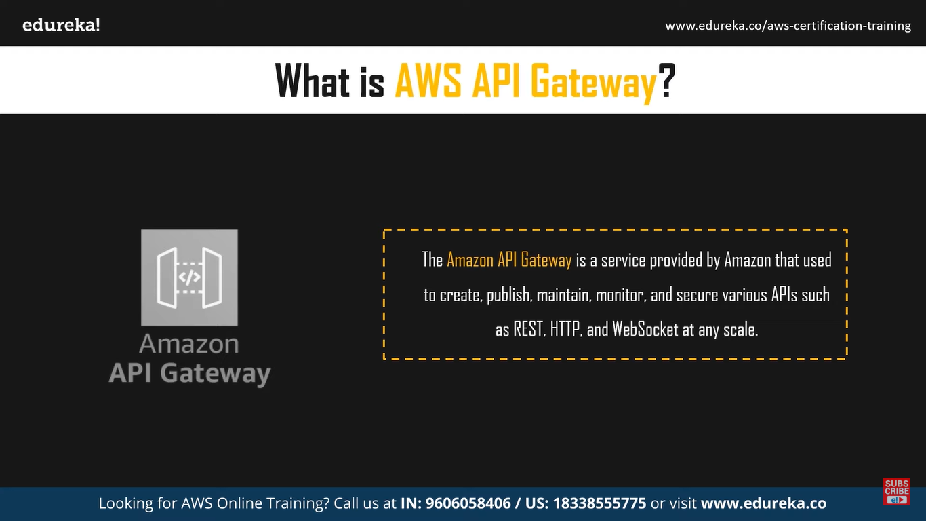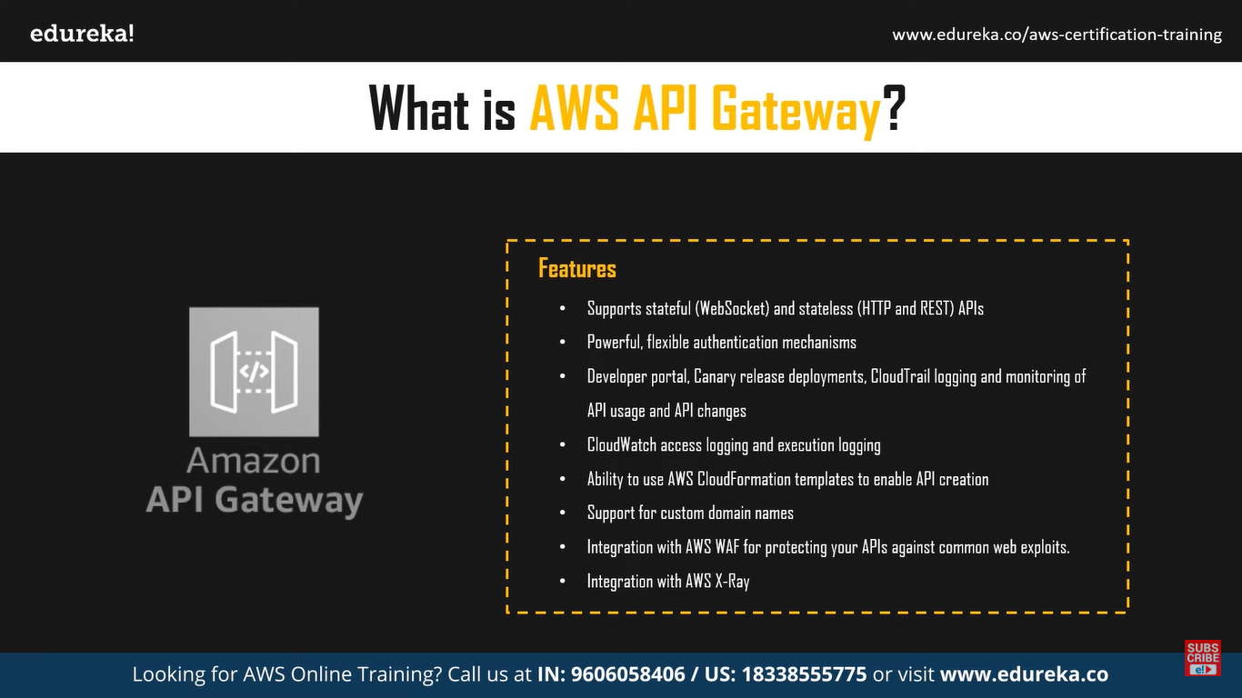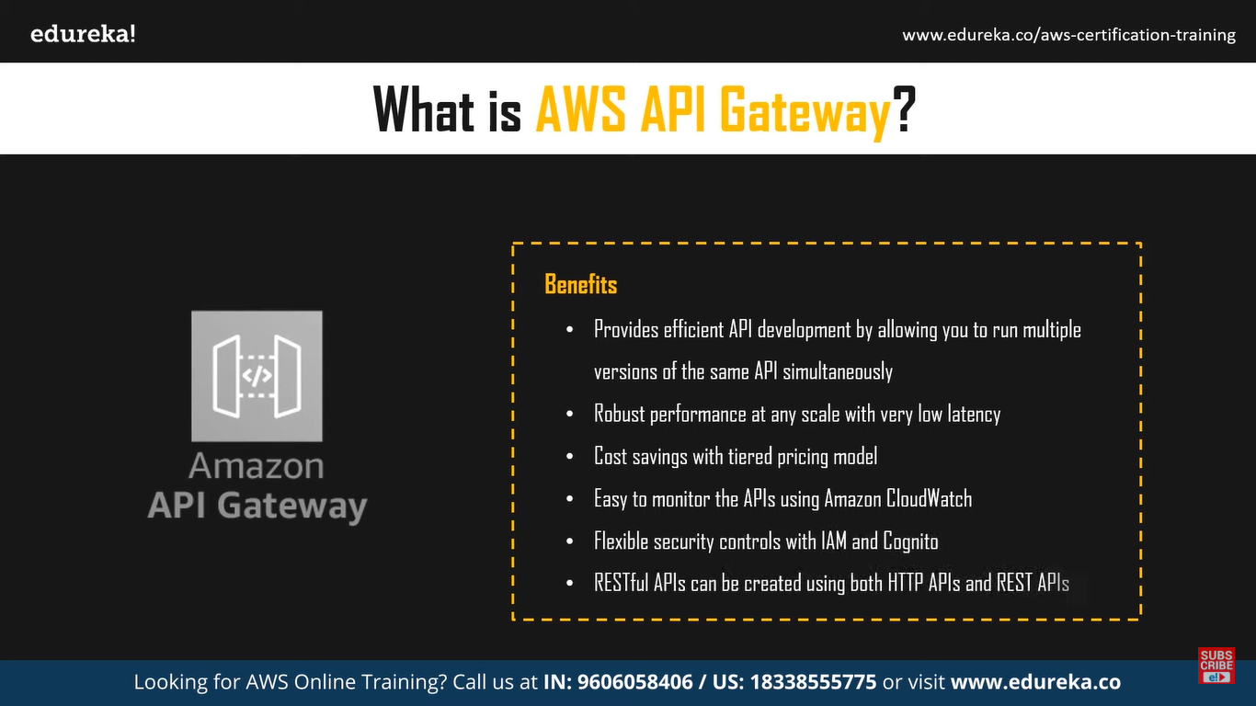

Terraform Script:

provider "aws" {  
 region = "us-east-1"  
}  
  
resource "aws_api_gateway_rest_api" "sample" {  
 name = "sample-api"  
}  
  
resource "aws_api_gateway_resource" "sample" {  
 parent_id = aws_api_gateway_rest_api.sample.root_resource_id  
 path_part = "sample"  
 rest_api_id = aws_api_gateway_rest_api.sample.id  
}  
  
resource "aws_api_gateway_method" "sample" {  
 authorization = "NONE"  
 http_method = "GET"  
 resource_id = aws_api_gateway_resource.sample.id  
 rest_api_id = aws_api_gateway_rest_api.sample.id  
}  
  
resource "aws_api_gateway_integration" "sample" {  
 http_method = aws_api_gateway_method.sample.http_method  
 resource_id = aws_api_gateway_resource.sample.id  
 rest_api_id = aws_api_gateway_rest_api.sample.id  
 type = "MOCK"  
}  
  
resource "aws_api_gateway_deployment" "example" {  
 rest_api_id = aws_api_gateway_rest_api.sample.id  
  
 triggers = {  
 redeployment = sha1(jsonencode([  
 aws_api_gateway_resource.sample.id,  
 aws_api_gateway_method.sample.id,  
 aws_api_gateway_integration.sample.id,  
 ]))  
 }  
  
 lifecycle {  
 create_before_destroy = true  
 }  
}  
  
resource "aws_api_gateway_stage" "example" {  
 deployment_id = aws_api_gateway_deployment.example.id  
 rest_api_id = aws_api_gateway_rest_api.sample.id  
 stage_name = "sample"  
}

